

Newsletter Oct-Dec 2025


PSD Nepal, 1766/45 Ganeshman Singh Path,
Kathmandu, Nepal.
©
Web: www.psdnepal.org Email: info@psdnepal.org
Director: Bishnu Bhatta

Quarterly Newsletter Year 20, No. 4 October-December
PSD Connect, a quarterly e‐newsletter by the Partnership for Sustainable Development (PSD) Nepal, keeps our partners, former volunteers, and long‐term supporters updated on our activities and news. As a non-profit focused on alleviating poverty among Nepal’s rural youth and children, we’re driven by a mission of sustainable development. For more details, please visit our website: www.psdnepal.org

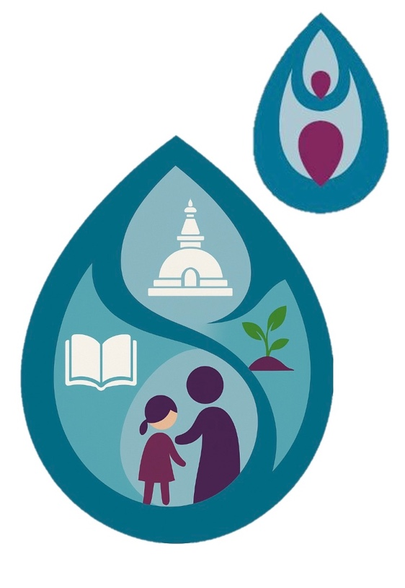
Message from the EDITOR
Namaste, friends!
We are delighted to present the second issue of our 20th year, our latest quarterly newsletter with you. This newsletter brings you closer to PSD Nepal’s world, showcasing our initiatives, projects, and future. We eagerly anticipate your questions, comments, and insights. Feel free to share this newsletter and spread the word about our efforts. Your feedback is invaluable to us! Reach out at psdnepal@gmail.com or call (+977)-9841285379
Warm regards,
Bishnu H. Bhatta

In Reflection and Solidarity
The recent Gen-Z protests across Nepal have deeply affected us all. As an organization that works closely with youth, teachers, and local communities, we at PSD Nepal feel a strong responsibility to pause, listen, and reflect.
We extend our heartfelt condolences to all families who have lost their children, friends, and loved ones during this difficult time. The voices raised in the streets remind us that the next generation is yearning for justice, opportunity, and inclusion. PSD Nepal stands in solidarity with them, reaffirming our commitment to building pathways of peace, empathy, and empowerment for Nepal’s youth.


Latest PSD Nepal News
A new Digital Home for PSD Nepal
We are delighted to announce the launch of our newly redesigned website! The new platform offers a fresh, modern look with improved navigation, updated project pages, and a stronger focus on community stories and visual impact. Visitors can now easily explore PSD’s ongoing initiatives across education, health, environment, and social inclusion - as well as opportunities to collaborate, volunteer, or support our mission. The redesign reflects PSD’s values of transparency, accessibility, and participation, ensuring that our message of sustainable development reaches more people in Nepal and beyond.

360Life Teacher Training in Baglung – Building Trauma-Informed Classrooms
In October, PSD Nepal, in collaboration with the CRED Foundation (UK), conducted a two-day 360Life Teacher Training in Kathekhola Rural Municipality, Baglung, led by Dr. Helen Harrison. The workshop gathered 45 dedicated teachers representing over 35 local schools, many of whom traveled long distances - up to three hours on rough mountain roads with altitude gains of more than 1,500 meters - to take part.
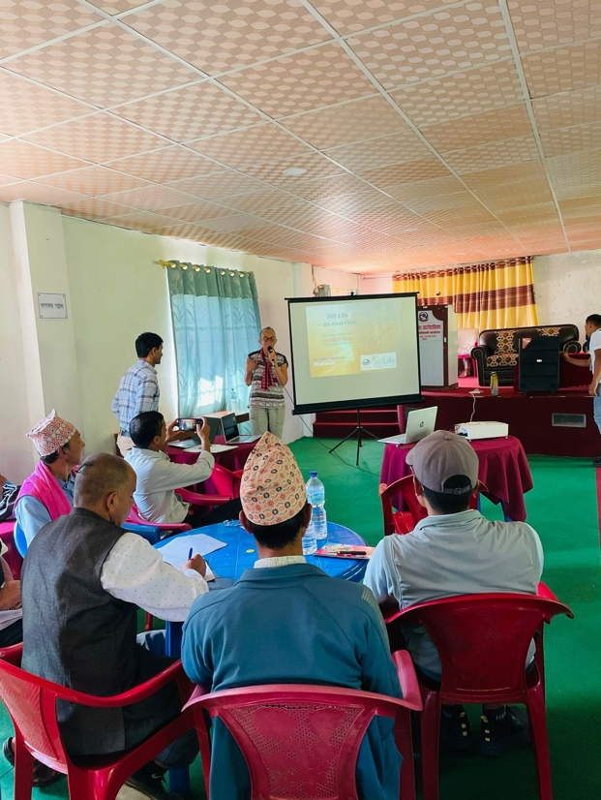
Despite the challenges posed by landslides and public holidays that delayed some participants, the training went ahead in what must be one of the most scenic venues in rural Nepal. The focus was on helping teachers develop a trauma-informed approach suited to the Nepali context. Participants explored how the brain processes learning and stress, how trauma impacts behavior, and how empathy and active listening can create safer, more nurturing classroom environments. Group discussions provided space for teachers to reflect on their own challenges - ranging from students facing mental health issues and parental absence due to overseas work, to the lingering effects of natural disasters and economic uncertainty. For many, it was the first opportunity to share experiences openly in a professional, supportive setting.
Dr. Harrison adapted her training to Nepal’s diverse cultural and religious context, engaging both Hindu and Buddhist teachers in thoughtful conversations about compassion, resilience, and healing. The feedback was deeply positive, with participants expressing renewed motivation and confidence to care for their students’ emotional well-being. PSD Nepal and CRED are now exploring options for follow-up online sessions and a train-the-trainer program to extend the impact of this initiative to more schools and communities across Nepal.

Latest PSD Nepal News
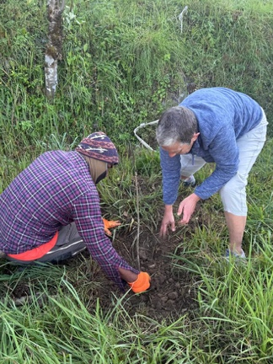
Tree-Plantation in Sima, Baglung
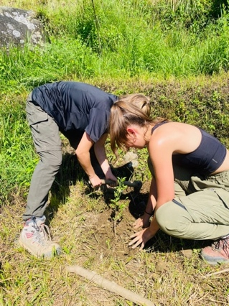
In October 2025, PSD Nepal, with generous support from the World Challenge Program (UK), carried out a tree plantation activity in Sima, Baglung, as part of its long-term environmental and livelihood program. The plantation took place on October 11 on community-owned land identified by local leaders for its fertile soil and easy access. A total of 200 walnut and lemon saplings were planted by six residents together with PSD interns Elisa Ibel and Lara Kraushaar, under the coordination of Executive Director Bishnu H. Bhatta. Dr. Helen Harrison from the CRED Foundation (UK) also joined the activity hands-on while in Nepal for teacher training. The two tree species were selected for their economic value, climate resilience, and low maintenance needs, offering both income opportunities and environmental restoration for rural families. Originally, twelve World Challenge students from the UK were scheduled to participate, but due to travel restrictions PSD Nepal continued the project on their behalf - a gesture of trust and partnership that ensured its success. Early observations showed healthy soil and strong sapling growth, and local participants expressed commitment to caring for and expanding the plantation.
The Sima plantation reflects PSD Nepal’s broader agroforestry approach, promoting reforestation, sustainable farming, and livelihood diversification in Nepal’s hill districts. Follow-up visits will monitor growth and provide further training in organic fertilization, maintenance, and pest control to secure long-term success.

Evaluation Long-Term Impact: Tree Plantation Follow-Up
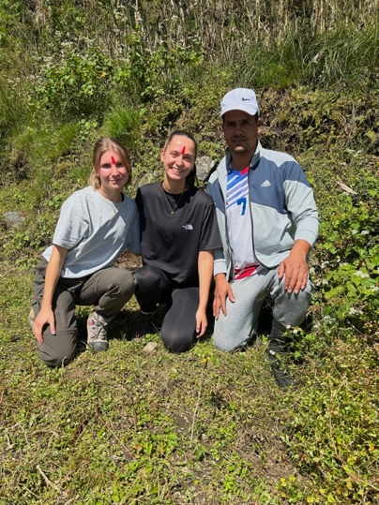
Following the new plantation in Sima, PSD Nepal carried out an evaluation of earlier tree plantation projects in Baglung to assess their long-term sustainability and community impact. Out of ten participating families, three households were interviewed in detail about the health and survival of their trees, their maintenance practices, and the social and economic benefits they have observed.
In total, around 1,200 trees were planted across the ten households, with each family cultivating between 100 and 150 saplings. The results of the evaluation were highly encouraging: families reported average survival rates between 70 and 95 percent, with lemon trees performing particularly well under rising temperatures and walnut trees remaining the most valuable cash crop. Regular watering, the use of organic fertilizers such as buffalo manure, and consistent grass removal were identified as key factors for success. Beyond the statistics, the plantations have generated a deep emotional connection within the communities.
Latest PSD Nepal News
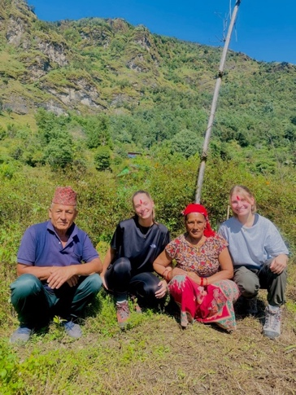
Families spoke of their trees as symbols of stability, pride, and hope for future generations. Older residents expressed joy at being reconnected to their land, while younger family members showed growing enthusiasm for sustainable agriculture. The initiative has even inspired neighboring households to begin planting trees independently, extending the positive environmental and social effects throughout the village.
PSD Nepal will continue to monitor and expand these efforts by supporting families with training in organic pest management, mixed fruit cultivation, and beekeeping, promoting both ecological diversity and economic resilience in the region.

Field Visits & New Initiatives
- Pokhara – Himalayan Plastic Center Visit
PSD Nepal visited the Himalayan Plastic Center, a pioneering social enterprise that transforms mountain waste into useful products. The visit explored future collaboration on plastic recycling education and community awareness programs.
- Gosainkunda (Rasuwa) – Elderly Home Proposal
PSD Nepal met with the Mayor of Gosainkunda Rural Municipality to advance the proposal for the Dhunglang Jomkhang Home, a planned community facility for elderly citizens, single women, and persons with disabilities. The home will serve as a safe, inclusive, and dignified space offering day-care, cultural exchange, and skill-building activities, addressing a major gap in social care services in rural Nepal.
PSD’s team also discussed with different people in Rasuwa to identify land and discuss the next steps for the upcoming Samuel Memorial House, envisioned as a local community and youth resource center promoting education, innovation, and sustainable livelihoods.

Latest PSD Nepal News
Research & Documentary: Voices of Climate Resilience
In mid-2025, Partnership for Sustainable Development (PSD) Nepal completed an important study titled “Climate Resilience and Equity in Nepal: Voices of Children, Youth, and Elderly,” made possible through the generous support of the Global Fund for Children (GFC). The research, led by PSD’s Executive Director Mr. Bishnu Hari Bhatta together with a multidisciplinary team, explored how climate-induced disasters such as floods and landslides affect children, youth, and elderly populations across five districts — Kathmandu, Kavre, Bara, Rautahat, and Sindhuli. Conducted between June and July 2025, the study combined surveys, focus group discussions, and key informant interviews to document lived experiences, perceived risks, and emotional well-being in disaster-prone communities. Forty-three participants shared their stories, offering a rare multi-generational perspective on what it means to live with recurring floods, disrupted schooling, health challenges, and uncertainty for the future. The findings revealed that children experience the highest psychological impact of disasters, reporting deep fear, anxiety, and disrupted education, while youth spoke about livelihood insecurity and loss of identity documents, and elderly participants emphasized health vulnerabilities and mobility challenges. Across all groups, there was a shared sense of resilience, solidarity, and readiness to act - communities often worked together to warn neighbors, move belongings, and build makeshift flood barriers when official early-warning systems failed.
The research identified a crucial gap between Nepal’s strong national climate policies and their local implementation, showing that many rural systems remain reactive and under-resourced. PSD Nepal’s report calls for a shift toward community-centered resilience building - empowering youth committees, improving local early-warning systems, and integrating mental health support into disaster response and school curricula. To bring these stories to life, PSD Nepal also produced a short documentary film during field visits to Kavre, Bara, Kathmandu, Rautahat and Sindhuli. The video features powerful interviews with children, young people, and elderly residents who shared their experiences of flooding, fear, and hope. Filmed with local researchers and translators, it captures not only data but the human voices behind the statistics - portraying courage, empathy, and the determination to rebuild lives amidst the challenges of climate change.
Mr. Bishnu Hari Bhatta, who supervised the fieldwork and community engagement, emphasized that “these stories are not only evidence but a reminder - that resilience begins when those most affected are heard.” PSD Nepal and GFC aim to use this research and film as advocacy tools to inform policymakers, support community education, and promote inclusive climate action rooted in local realities.
PSD Nepal extends its heartfelt gratitude to Global Fund for Children for their generous and unwavering support. This achievement would not have been possible without GFC’s commitment to our work. Thank you, GFC, for continuously believing in our initiatives and empowering us to create meaningful impact in the lives of children and communities.

Latest PSD Nepal News
PSD Nepal at COP30
It was a moment of pride and joy for PSD Nepal when Executive Director Bishnu H. Bhatta and Vice-Chairperson Dr. Suresh Tiwari took the stage at COP30 in Belém, Brazil, to present the organization’s latest research and documentary “Voices of Climate Resilience”, produced with support from the Global Fund for Children. In front of an international audience, they shared inspiring stories from children, youth, and elderly people in Nepal who are facing climate-induced floods and landslides with courage and hope. The presentation combined powerful data with emotional storytelling, and the short film deeply moved participants, many describing it as a “reminder of why climate action must stay human.”
Speaking with pride, Bishnu and Suresh highlighted Nepal’s resilience and called for stronger investment in community-led adaptation, mental health support, and education. PSD Nepal’s presence at COP30 marked a truly celebratory milestone - placing the voices of Nepali communities on the global stage and reaffirming the organization’s commitment to building a more just and hopeful climate future.

Sport Connect – Movement, Mind & Motivation
In November, two German interns Elisa Ibel and Lara Kraushaar organized the Sports Connect Event at Saraswati Boarding Secondary School, held twice over two weeks to ensure that all 900 students could participate twice in the sessions. The event was designed to connect mental health, fun, and physical activity, helping children regain positivity and balance after the difficult months marked by protests, landslides, and uncertainty. To music and tailored to each age group, the sessions included energizing warm-ups, affirmation talks, creative choreographies, and exercises for all major muscle groups to strengthen the body and counteract imbalances. Teamwork activities encouraged mixed-gender collaboration, promoting inclusion, empathy, and a sense of community among students. Each child also received a worksheet to deepen their understanding of mental health, movement, and how caring for one’s body contributes to long-term well-being. Through these interactive lessons, the event reminded students that movement is not just about fitness, it’s a path to resilience, confidence, and joy.
To close the sessions, students filled out anonymous evaluation forms, sharing their feedback openly and without fear of judgment. Their overwhelmingly positive responses reflected laughter, learning, and renewed motivation - proof that a little movement can spark a lot of hope.

Latest PSD Nepal News
Looking Ahead
PSD Nepal remains steadfast in its vision of sustainable and inclusive community development. Our recent activities, from tree planting to teacher training and elderly care planning, demonstrate how small, consistent actions can create lasting change. We express our deep gratitude to all partners, local leaders, teachers, and volunteers who walk this journey with us. Together, we continue to nurture resilience, hope, and harmony across Nepal’s communities.

Vote of Thanks
PSD Nepal extends heartfelt thanks to all our volunteers, supporters, and partners who have contributed to our projects and programs over the years. Your dedication and support have been instrumental in our journey towards sustainable development. We are elated to share that the PSD team has accommodated 2,200+ volunteers in 23 years.

News subscribers
To subscribe to PSD Connect, click the button below.
For a healthier world and a sustainable future, PSD Nepal remains committed to innovation, collaboration, and action. Join us in our mission.

Donate
Subscribe

